Part 1: Practical Implementation — Coding the Architectures Step

1.1: Setting the Trap (Partial Observability)

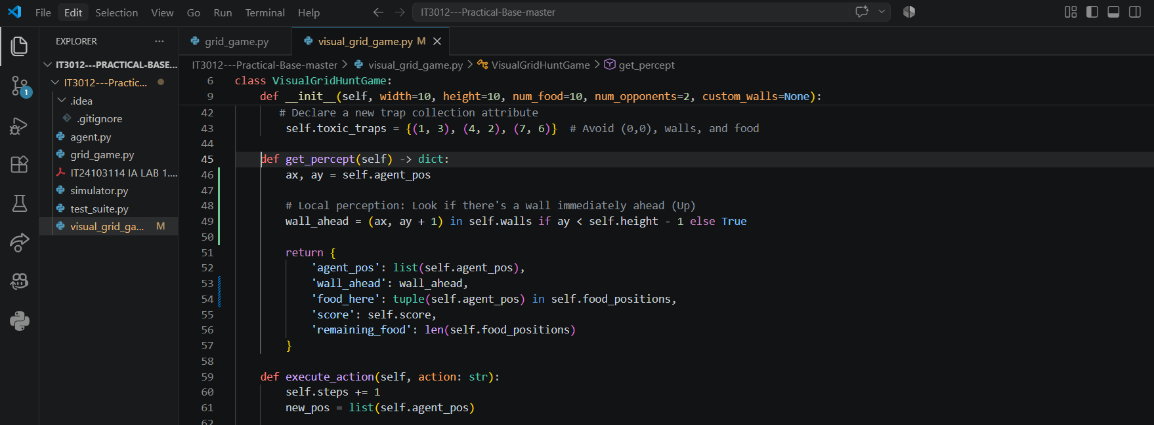

Step 1.2: The Simple Reflex Agent (Implementation & Failure)

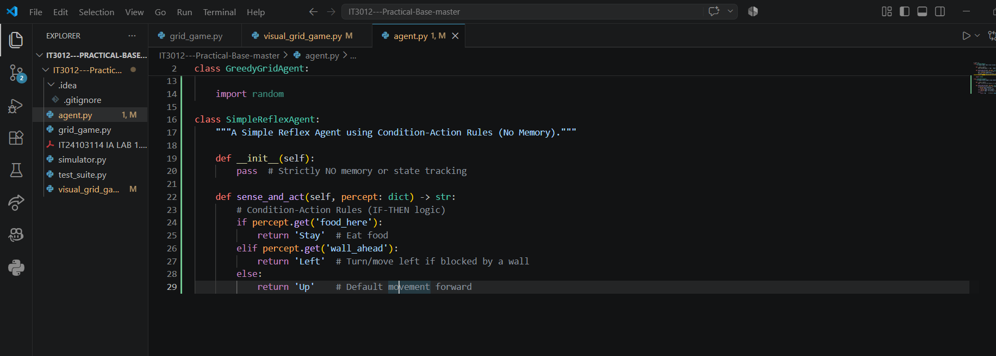

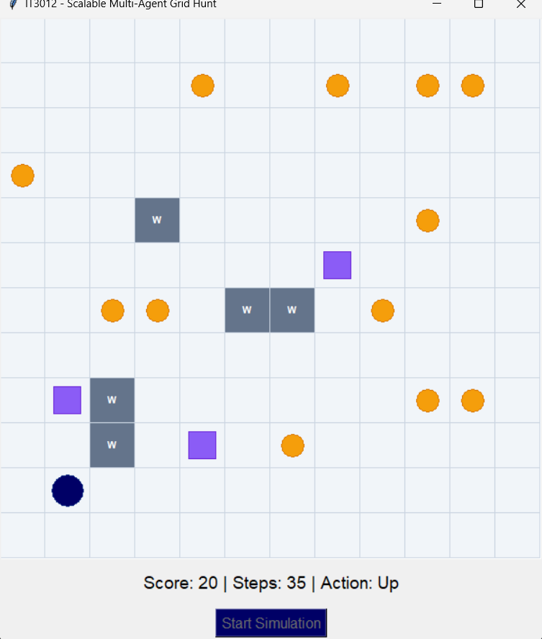

Step 1.3: The Model-Based Agent (Memory & State)
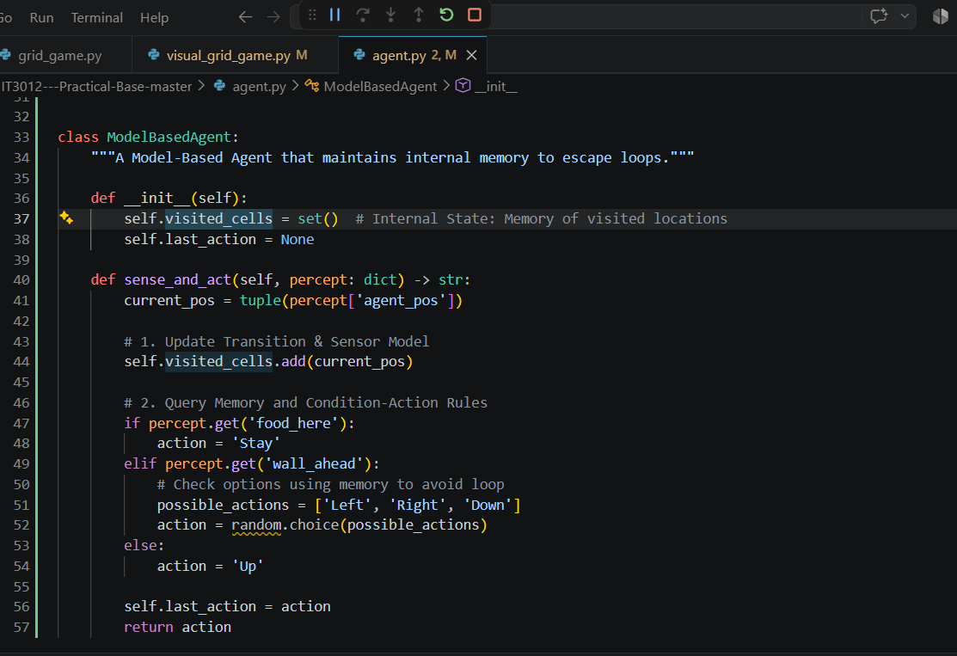
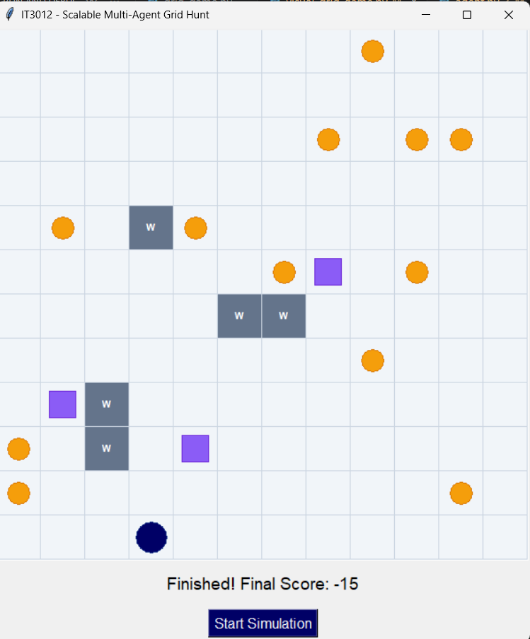
Q1: According to Lecture 02, why is it impossible to program a mathematically perfect "Table-Driven Agent" for complex environments like Chess? What happens as the agent's lifetime increases?
Answer: A Table-Driven Agent explicitly stores a lookup table mapping every possible percept sequence to an action. In complex environments, the number of possible percept sequences grows exponentially over time ($P^{t}$). This leads to a combinatorial explosion, making the table lookup size infinitely huge, requiring impossible amounts of storage and computational lookup time.
Q2: Look at the code you wrote for your SimpleReflexAgent. Identify and explain the specific lines of code that represent the "Condition-Action Rules".
Answer:
In SimpleReflexAgent.sense_and_act(), the lines:
Python
if percept.get('food_here'): return 'Stay'
elif percept.get('wall_ahead'): return 'Left'
else: return 'Up'
represent the Condition-Action Rules. They directly map current local perceptions (e.g., wall_ahead) to an immediate actuator movement ('Left') without consulting history.

Q3: Analyze exactly why the SimpleReflexAgent gets stuck in an infinite loop. How did "Partial Observability" and a lack of "Percept History" cause this failure?
Answer: Under partial observability, the agent only sees immediate adjacent cells (wall_ahead) and lacks full map awareness. Because it has no percept history/memory, every time it faces a wall, it evaluates the exact same condition and executes the exact same action ('Left'). Since the state doesn't break automatically, it loops infinitely between the same set of grid cells.
Q4: Evaluate how your ModelBasedAgent code handles the "Transition Model" and "Sensor Model".
Answer:
- Sensor Model: Handled when reading percept['agent_pos'] to determine the current state from raw percepts.
- Transition Model: Handled by self.visited_cells.add(current_pos) and tracking self.last_action, which updates internal memory about how actions alter position over time. This internal state allows the rule base to choose unvisited/alternative paths and break infinite loops.

